***Association of Benedictine Colleges and Universities (ABCU*)**

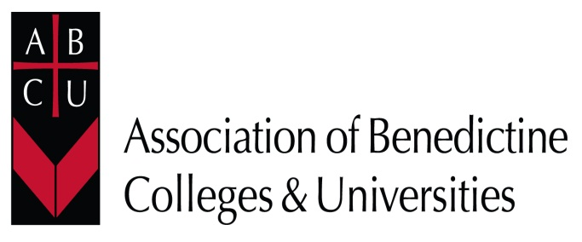

**ABCU Annual Conference**

**June 23 – June 25, 2025**

(departure morning of June 26)

**Saint Anselm College**

**Manchester, New Hampshire**

# <https://www.abcu.info>

*Rooted in Tradition: Benedictine Leadership & Learning in Higher Education*

**Monday, June 23**

2-4:30  **Arrival & Check-in**

5:35  **Evening Prayer** (*all are welcome and encouraged to attend all prayer opportunities*)

6:15 **Welcome Reception/Dinner**

7:30 **Opening Keynote**

**Tuesday, June 24**

7:30-8:15 **Breakfast**

8:30 **Mass**

9:15-10:30 **SESSION 1**

10:45-11:45 ***Lectio* *Divina –* Introduction/Application**

12:00 **Midday Prayer** *(optional)*

12:15-1:45 **Lunch with Roundtable Discussions**

2:00-3:15 **SESSION 2**

3:45-4:45 **Monastic Social**

4:45-5:30 **Free Time**

5:35  **Mass**

6:30 **Dinner**

## **Wednesday, June 25**

7:30-8:15 **Breakfast**

8:30 **Mass**

9:15-10:30 **SESSION 3**

10:45-11:45 ***Lectio* *Divina –* Introduction/Application**

12:00 **Midday Prayer** *(optional)*

12:15-1:30 **Lunch with Roundtable Discussions**

1:45-3:00 **SESSION 4**

3:15-4:45 **Workshop**

4:45-5:30 **Free Time**

5:35  **Mass**

6:15 **Closing Social/Dinner**

7:30 **Closing Keynote**

**Thursday, June 26 – Participants depart after breakfast and Mass (optional).**